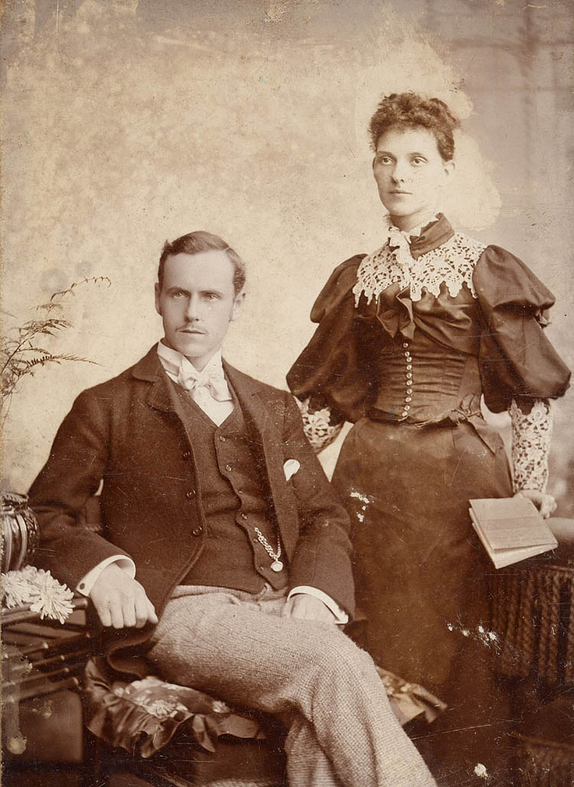
Introduction of Sepia in Photos
A sepia photograph is a black and white image that has a warm brown tint. Sepia tints can make a photograph look older, and they are popular in contemporary photography.
The warm brown tints associated with sepia photography give pictures a classic, old-fashioned feel. Sepia tones can be romantic and are often used in wedding photography. Adding a sepia tone to a black and white photograph softens the image, giving it a warm, dreamy feeling.

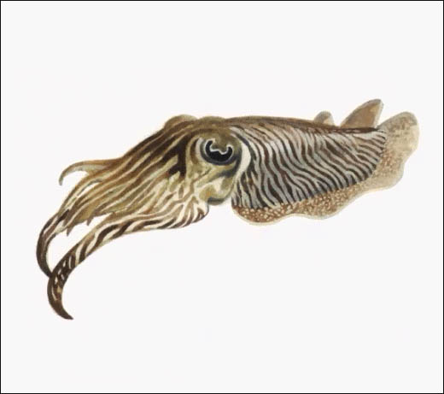
Sepia pigment was originally made from sepia cuttlefish, and used to treat photographs. Sepia-treated prints are more durable and designed to last longer. During the developing of the print, sepia pigment would be added and it would turn any remaining silver in the print into a sulfide.
Many of the photographs and portraits done in the 1700s were treated with sepia during the development process. Any painting or drawing, such as Leonardo de Vinci's drawings, created with the reddish-brown sepia pigment is sepia tone.

Treating Photos with Sepia
Photographers who shoot with film can have their black and white images treated with sepia. Not all photographers have their own darkroom and therefore have to find a professional photo developing shop. Sepia tone development can be expensive, and for many photographers, it is more cost effective to find alternative, computerized methods of adding sepia tones.

Digital Sepia Toning
Most computer imaging software offers ways of adding sepia tones to an image. However, all that is being added to the photograph are the brown hues associated with sepia tone; the final image will not have the longevity associated with sepia-treated prints. Today, photographers use simulated or virtual sepia toning for a historical effect.
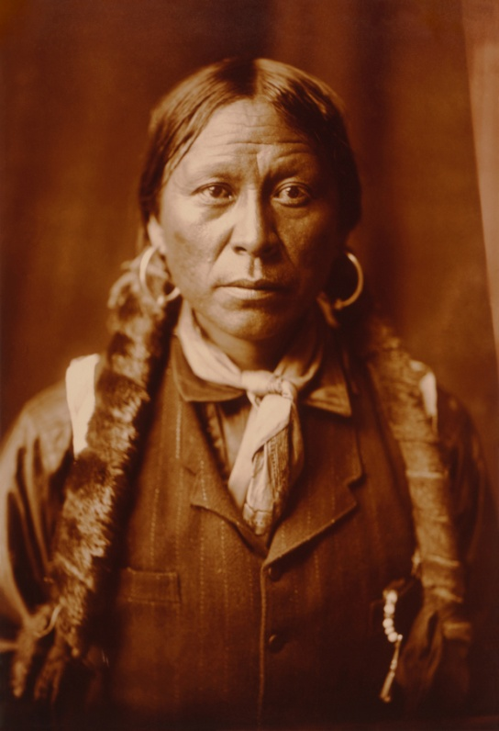
History
The sepia tone process for photography developed in the 1700s as a preservation treatment. Stored in identical conditions, photos fixed with sepia-tone (silver sulfide) survived up to 50 percent longer than standard black and white prints fixed only with silver. As modern processes for fixing photographic emulsions became available early in the 20th century, use of sepia tone declined.

Answer the questions below and highlight where the answers are found in the reading. Also go on the web and search and find 20 historiacal sepia toned pictures and save them in a folder you create and make a contact sheet of them.

- What is a Sepia Photograph?

- What does Sepia do to a photograph?

- Where did Sepia pigment come from?

- What is a cheaper way of doing a Sepia Photograph?

- What will a Digital Sepia print lack?

- How much longer will a Sepia treated print last verus a traditional Black and white print?

